Lab 1: Knowing your Lab workbench.

PRE-LAB Exercises.
PRELAB1-1.-Describe briefly the function of each of the following instruments: oscilloscope, digital multimeter, function generator, power supply, and data acquisition board. Explain their main characteristics and draw a model of their input or output circuits.
- Oscilloscope: The function of an oscilloscope is to display electronic signals as a visual representation, typically a waveform, on a screen. It allows engineers and technicians to observe and analyse the behaviour of electronic circuits by measuring and graphically displaying the voltage and time relationship of a signal. The oscilloscope that is used in the laboratory has a bandwidth of 70MHz to 300MHz, a sample rate up to 250Msample/s, a memory depth up to 20 Msample/channel and a DC resolution of 10 bits.
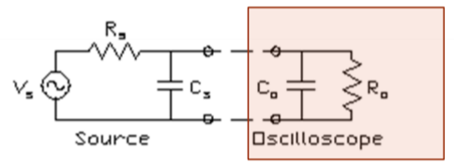
- Digital multimeter: is a test instrument used to measure multiple electrical quantities, typically voltage, current, and resistance. It provides a numerical readout on a digital display and is commonly used to diagnose and troubleshoot electrical and electronic circuits. The main characteristics of the digital multimeter used in the lab can measure from 100mv to 1000V, from 100 Ohms to 1 GOhm and from 1µ to 10A.
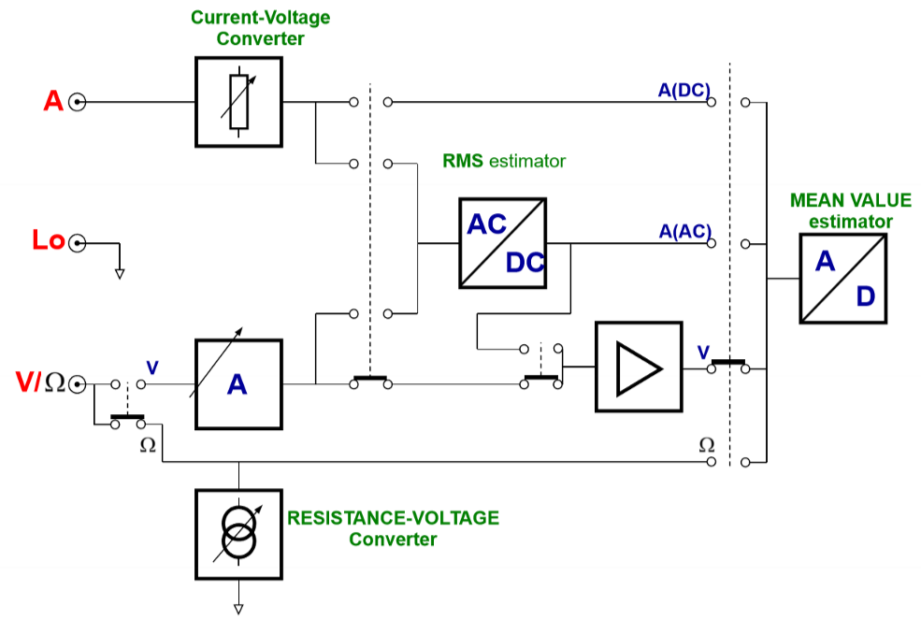
- Function generator: it is an instrument that can generate standard waveforms, mostly sine and square waves with different frequencies but also triangle noise and DC waveforms. The function generator used in the laboratory has AM, FM, PM, FSK and PWM modulation types and 10mVpp to 10 Vp amplitude range.
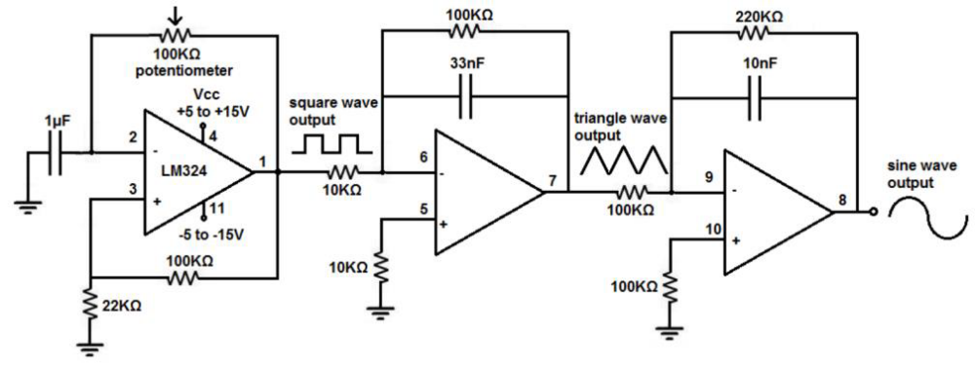
- Power supply: it is a device that generates electric power to a load. The main characteristics of the one used in the lab are output voltage of up to +25 V and output current of up to 5 A.
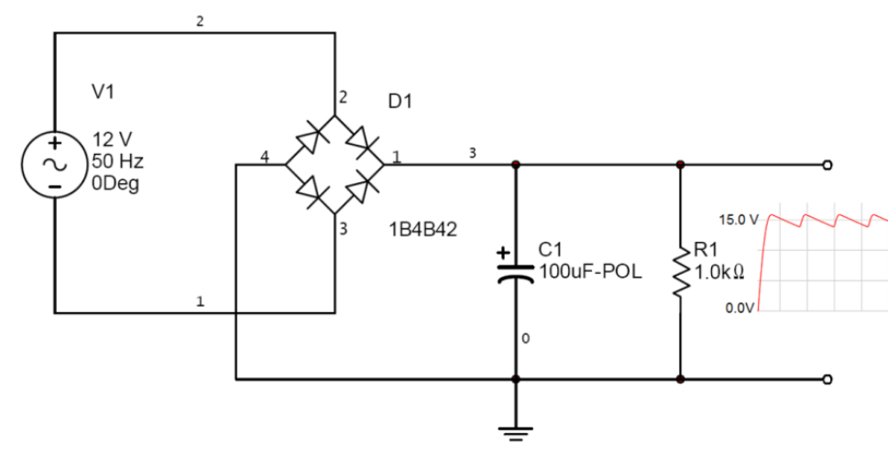
- Data acquisition board: It is a device used to transform analog signals into digital data, for processing by a computer. It is based on an analog-to-digital converter (ADC).
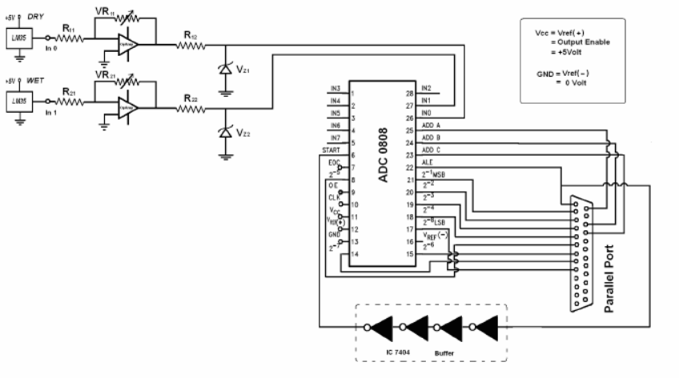
PRELAB1-2.- Look for the following definitions in the international vocabulary of metrology that you have in the readings folder of session 1: accuracy, repeatability, sensitivity, selectivity, and measurement uncertainty.
- Accuracy: closeness of agreement between a measured quantity value and a true quantity value of a measurand.
- Repeatability: measurement precision under a set of repeatability conditions of measurement.
- Sensitivity: quotient of the change in an indication of a measuring system and the corresponding change in a value of a quantity being measured.
- Selectivity: property of a measuring system, used with a specified measurement procedure, whereby it provides measured quantity values for one or more measurands such that the values of each measurand are independent of other measurands or other quantities in the phenomenon, body, or substance being investigated.
- Measurement uncertainty: non-negative parameter characterizing the dispersion of the quantity values being attributed to a measurand, based on the information used.
PRELAB1-3.- Let's suppose you want measure the amplitude a low voltage, low frequency signal (10 mVpp, 1 Hz) you could choose between the oscilloscope and the digital multimeter of your work bench. Consult the specifications of both instruments and try to calculate the measurement uncertainty when the oscilloscope is used and when the digital multimeter is used. Explain which instrument parameters you have considered and detail all your calculations.
- Oscilloscope:
$${Uncertainty}_{oscilloscope}=\frac{{10 mV}_{pp}×\frac{1.5}{100}+0.1 div×\frac{5 mV}{div}+1 mV}{\sqrt{3}}=9.53×{10}^{-4}$$
- Digital Multimeter:
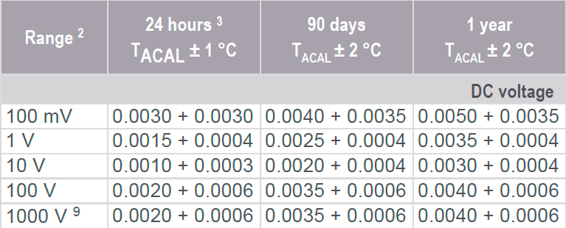
$${Uncertainty}_{multimeter}=\frac{10{ mV}_{pp}×\frac{0.005}{100}+100 {mV}_{pp}×\frac{0.0035}{100}}{\sqrt{3}}=2.3×{10}^{-6}$$
PRELAB1-4. - You want to characterize the uncertainty of the function generator. From the instrument specifications try to calculate the uncertainty in amplitude and frequency at the following frequencies 1 Hz, 10 Hz, and 1 kHz. Suppose you have 1 Vrms of amplitude.
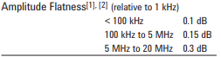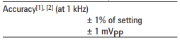
$${Uncertainty}_{1Hz}=\frac{{10}^{\frac{0.1}{100}}+{1 V}_{rms}×\frac{1}{100}+\frac{{1 mV}_{pp}}{\sqrt{2}}}{\sqrt{3}}=0.6$$
$${Uncertainty}_{10 Hz}=\frac{{10}^{\frac{0.1}{100}}+{1 V}_{rms}×10×\frac{1}{100}+\frac{{1 mV}_{pp}}{\sqrt{2}}}{\sqrt{3}}=0.6$$
$${Uncertainty}_{100Hz}=\frac{{10}^{\frac{0.1}{100}}+{1 V}_{rms}×100×\frac{1}{100}+\frac{{1 mV}_{pp}}{\sqrt{2}}}{\sqrt{3}}=1.15$$

PRELAB1-5.- If you measure the previous signal, calculate which is the measurement uncertainty due to the digital multimeter.
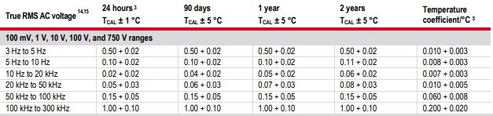
$${Uncertainty}_{1Hz}=\frac{{1 V}_{rms}×\frac{0.5}{100}+{1 V}_{rms}×\frac{0.02}{100}}{\sqrt{3}}=3×{10}^{-3}$$
$${Uncertainty}_{10 Hz}=\frac{{1 V}_{rms}×\frac{0.1}{100}+{1 V}_{rms}×\frac{0.02}{100}}{\sqrt{3}}=6.93×{10}^{-4}$$
$${Uncertainty}_{100Hz}=\frac{{1 V}_{rms}×\frac{0.05}{100}+{1 V}_{rms}×\frac{0.02}{100}}{\sqrt{3}}=4.04×{10}^{-4}$$

